Implementing VPN Solutions with FortiGate
Executive Summary
This project aimed to design and deploy a secure, resilient network infrastructure connecting a Headquarters (HQ) and a remote Branch office. Using Fortinet technologies (FortiGate VMs), the project successfully implemented remote access solutions (SSL VPN), site-to-site connectivity (IPsec), network optimization (SD-WAN), and unified threat management (UTM). The final topology ensures high availability with automated failover and strict security policies.
1. Project Topology & Design
- Infrastructure: Virtualized environment using VMware Workstation.
- Nodes: Two FortiGate Firewalls (HQ & Branch), two Ubuntu Linux endpoints.
- Network Segments:
  - HQ LAN: 10.0.11.0/24
  - Branch LAN: 10.0.22.0/24
  - WAN 1 (ISP 1): Simulated Internet (NAT Mode).
  - WAN 2 (ISP 2): Simulated Private Link (LAN Segment - 172.16.1.1).
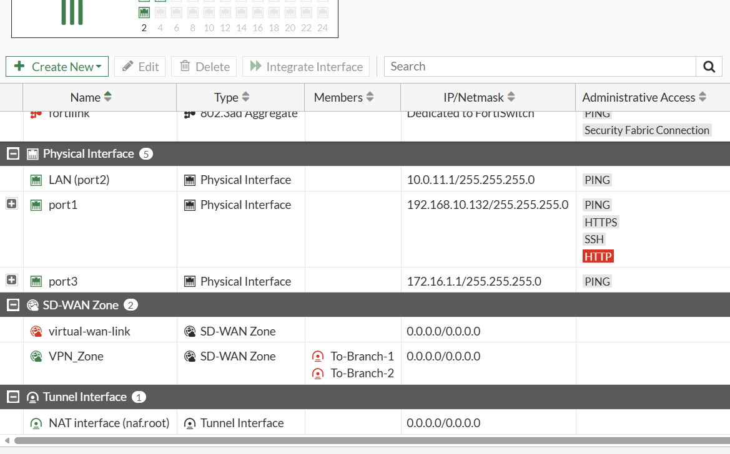

Remote Access Configuration (SSL VPN)
To support remote workers, an SSL VPN solution was deployed at the HQ.
- Configuration: Tunnel Mode with Split Tunneling enabled to optimize bandwidth.
- Authentication: Local user database with specific user groups (SSL_VPN_USERS).
- Testing: Successful connection established via FortiClient from an external host. Access verified via Ping to internal HQ resources.

Site-to-Site Connectivity (IPsec VPN)
A secure tunnel was established to connect the Branch office to the HQ.
- Protocol: IKEv2 with Pre-Shared Key authentication.
- Redundancy: Two distinct tunnels were created:
  - To-HQ-1 (via Public Internet).
  - To-HQ-2 (via Private Link).
- Status: Both tunnels achieved "UP" status in the IPsec Monitor.
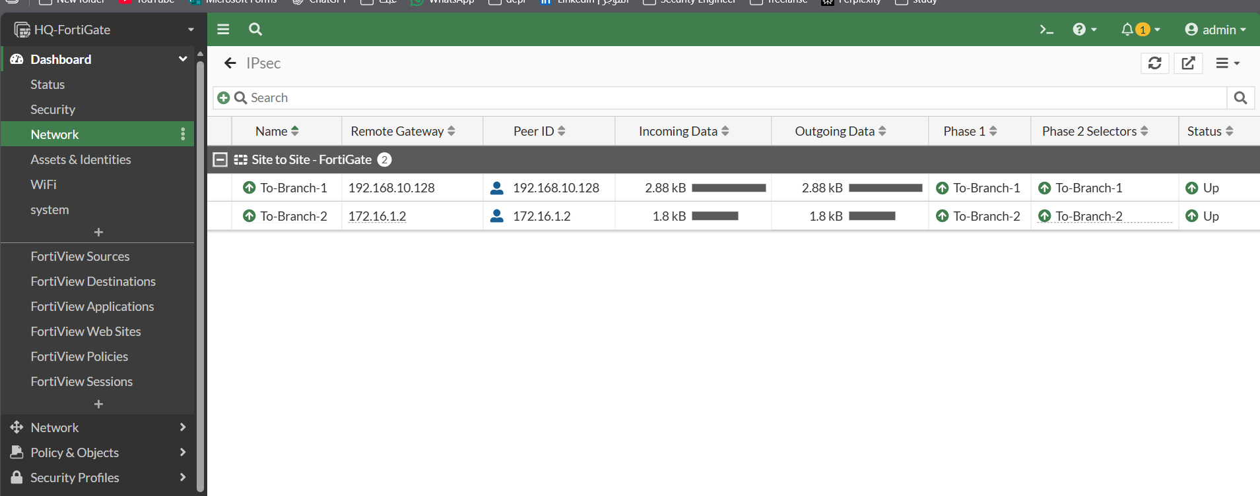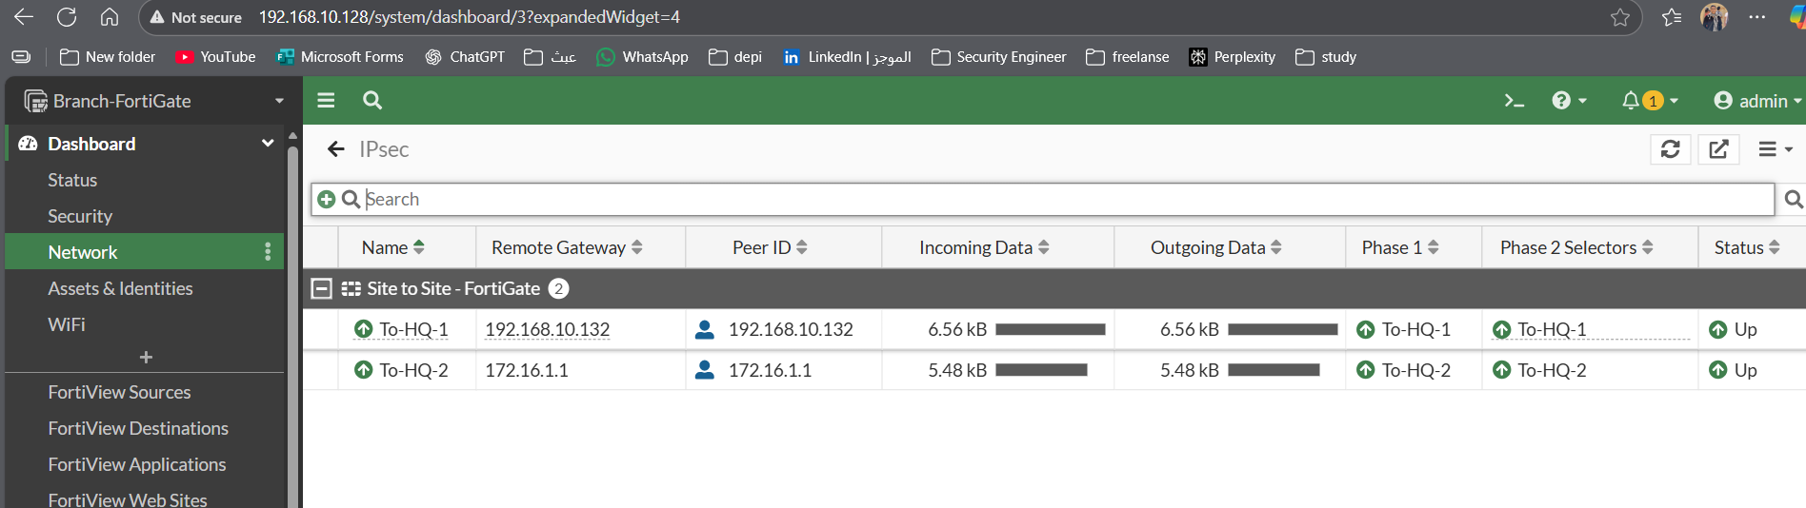

SD-WAN Integration & Optimization
To manage the dual tunnels efficiently, SD-WAN was implemented.
- Zone Configuration: Both IPsec tunnels were mapped to a single VPN_Zone.
- Performance SLA: A health-check monitor (Check-HQ) was configured using Ping to measure Latency and Packet Loss in real-time.
- Rules: Traffic steering rules were configured to select the "Best Quality" link.
- Failover Test: The primary WAN link was manually disabled. Traffic successfully failed over to the secondary link without interrupting active sessions.
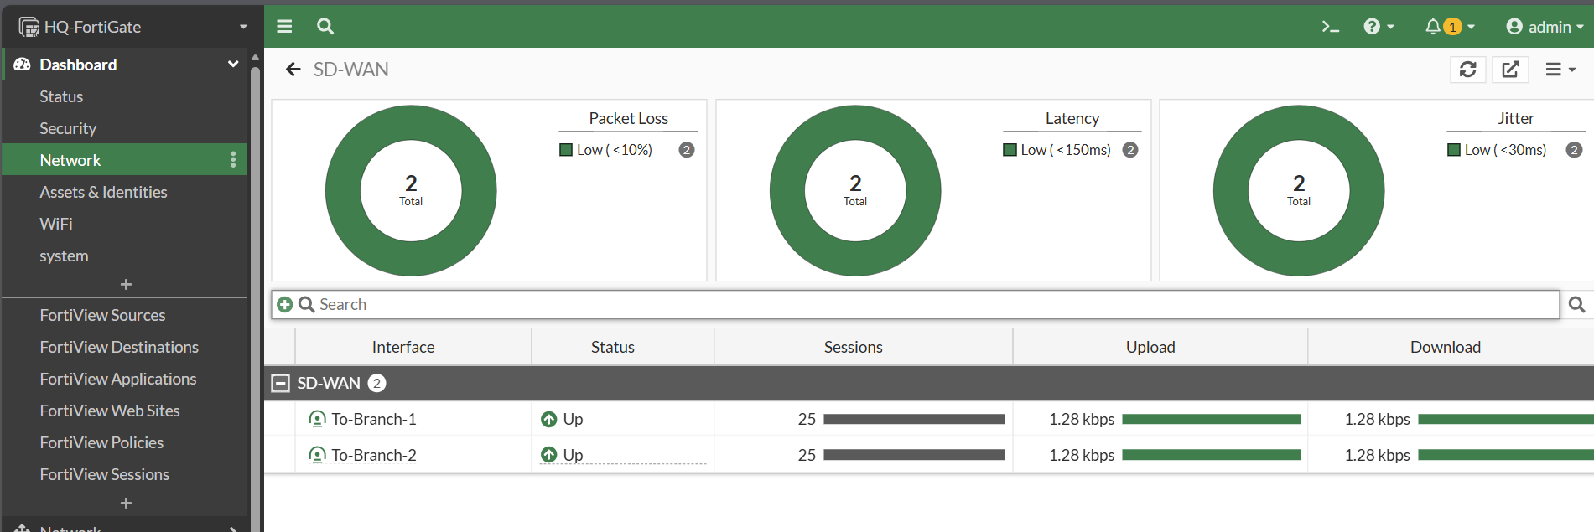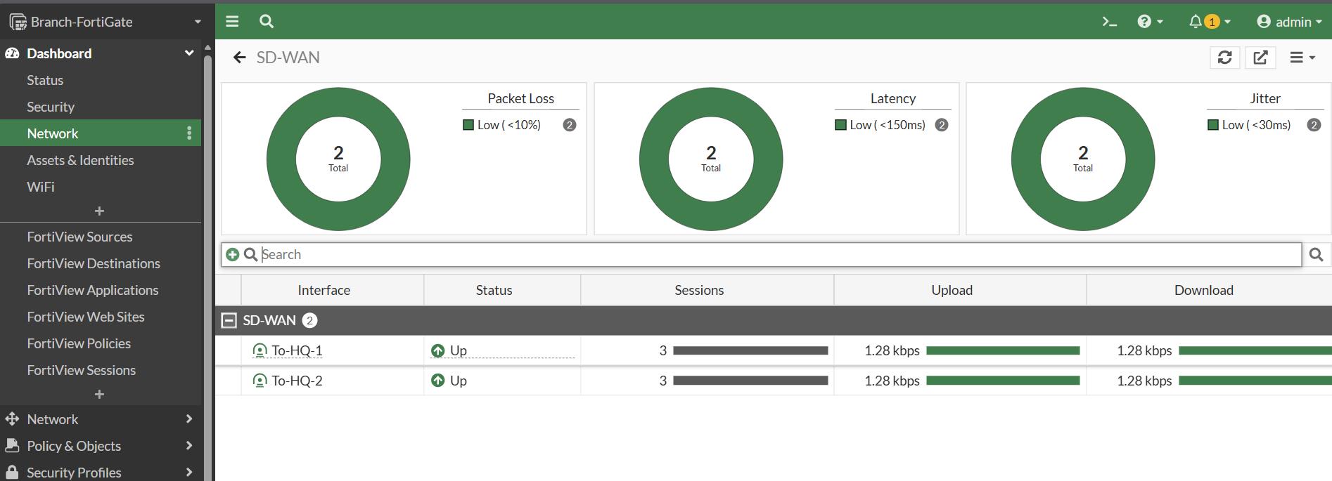

Security & Threat Management
To secure the open tunnels, security profiles were applied to firewall policies.
- Web Filtering: A Static URL Filter was applied to block access to specific unauthorized domains (e.g., social media).
- Verification: Attempts to access blocked sites from the Branch client resulted in a Fortinet "Web Page Blocked" warning.

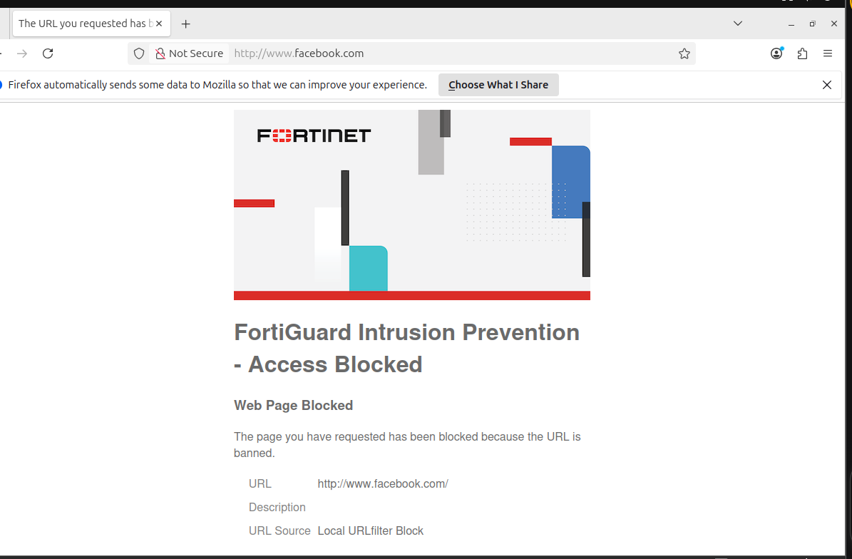
Conclusion
The project successfully met all objectives. The resulting network is secure, redundant, and optimized for performance. Future recommendations include integrating LDAP/Radius for centralized authentication and deploying FortiAnalyzer for advanced logging

